The security loopholes in COBIT itself

Chaoyang Li, Xin Shu, Huatai Xu, Zhibin Wan
Group 7
Dalarna University
Nanchang China
e-mail:
h20xinsh@du.se
h20zhiwa@du.se
h20huaxu@du.se
h20chali@du.se

Abstract—This paper focuses on the application of COBIT in the field of security, which includes two streams of research, overall management of security in an organization and the applicability of COBIT for specific IT area. We made a literature review about related paper, having a comprehensive understanding of COBIT application and its benefits in the field of security.
Keywords-component; COBIT, Security

Introduction
COBIT (control objects for information and related technology) is a common international framework for information system audit, which was published by ISACA in 1996. This is an internationally recognized and authoritative security and information technology management and control standard, which has been updated to COBIT 019. At present, COBIT has been applied in many fields. However, there are not a systemic description in its development in security field. This study will mainly discuss "What are the applications of COBIT in the field of security so far?” Our work will add more detail information base on George, Anil and Aakash’s work. (George Mangalaraj, Anil Singh, & Aakash Taneja, 2014)Summary the application of COBIT in the field of security before 2017, and provide some related information until now. Finally, our conclusion shows the benefits of COBIT when using it in an information security governance environment.

Literature review
The work of George (2014) and his partner helped summarize the application of the COBIT model in the security field before 2014 and divide the entire research into two directions. (George Mangalaraj, Anil Singh, & Aakash Taneja, 2014) First stream focused on the overall management of security in an organization. For example, Von Solms (2005) compares COBIT with ISO 17799 and use ISO 17799 as a ‘lower’ leveled guideline in which Information Security governance and state that COBIT as a ‘high’ level reference framework. (Solms, 2005) What’s more, there are studies that used COBIT for policy formulation (James L. Parrish, Jr., John R. Kuhn, Jr. , & James F. Courtney, 2008)
And the second stream of research focused on the applicability of COBIT for specific IT area. These studies dealt on how COBIT could be used in the management of security for Web services (Charuenporn, P. & Intakosum, S., 2012), Grr Rapid Response (Imam Riadia, Sunardib, & Eko Handoyoc, 2019), and reducing cyber-attacks on supply chain management system. (Wolden, Mark , Valverde, Raul , & Talla, Malleswara, 2015)

Research methodology
This study’s is based on the work of George, Anil and Askash (2014) (George Mangalaraj, Anil Singh, & Aakash Taneja, 2014) who performed a literature review and classification of studies before 2014. Then the paper explained their work in more detail and added some new researches which are published after 2014.
Firstly, researchers found the other four papers on COBIT security mentioned in the paper, so that the study had a rough idea of what the research was before 2014. During this period, the research was divided into two main directions, each with different applications.
Then according to the advices from Otabes, researchers systematically searched various databases to identify relevant research articles. Researchers use the library of Dalarna University as the entrance and used “COBIT” and “Security” as keywords to search papers, then the search year was narrowed down to 2014-2020, so that researchers can get papers for the ideal time period.
And researchers use "full-text online", "Journal Articles", "Magazine Article" as the search criteria. Then we got the first 20 articles sorted by relevance were got. But not all the 20 papers are new field studies, so by reading abstracts and sifting through keywords, we found two papers were found that dabble in new fields.
The following is the paper involved in the research：
George Mangalaraj, Anil Singh and Aakash Taneja | "IT Governance Frameworks and COBIT - A Literature Review," in Twentieth Americas Conference on Information Systems, Savannah, 2014.
B. v. Solms, | "Information Security governance: COBIT or ISO 17799 or both?" Computers & Security, no. 24, pp. 99-104, 2005.
James L. Parrish, Jr., John R. Kuhn, Jr. and James F. Courtney, | "Mindful Administration of  IS Security Policies," in American conference on information systems, Toronto, 2008.
Charuenporn, P. and Intakosum, S. | "Qos-Security Metrics Based on ITIL and COBIT Standard for," Journal of Universal Computer Science, pp. 775-797, 2012.
Imam Riadia, Sunardib and Eko Handoyoc, | Security Analysis of GRR Rapid Response Network, 2019.
Wolden, Mark, Valverde, Raul and Talla, Malleswara, | "The effectiveness of COBIT 5 Information Security Framework for reducing Cyber Attacks on Supply Chain Management System.,"
In order to obtain effective information, the research mainly focuses on the concepts mentioned in the paper, the application fields, the verification methods and the final effects. The specific results will be explained in detail in the next section.

overall management of security in an organization
First stream focused on the overall management of security in an organization. These studies focused on the applicability COBIT for security governance. For example, in organizations, COBIT is a good reference framework for information security governance. It mainly positions information security governance in a broader information technology governance framework, information security is ‘integrated’ into a larger or wider Information Technology governance framework, provided by the other 33 processes. Even if COBIT is used only for Information Security governance, it still provides the rest of the framework if the company later decides to base the rest of its Information Technology governance also on COBIT. The then existing Information Security governance framework will then fit seamlessly into the wider framework defined by COBIT.
However, COBIT is not very detailed in "how" to do certain things, it is more focused on "what must be done". While, ISO 17799 can just make up for the shortcomings in this regard, and provides more direct guidance for the "how". The problem is to determine how to integrate them e i.e., which DCOs of COBIT map to which elements of ISO 17799 and vica versa. This article then also proposed a solution to this problem, namely COBIT Mapping: Mapping of ISO/IEC 17799:2000 with COBIT. And, based on this mapping, the complementary use of the two frameworks in information security governance is discussed in cases and scenarios. Finally, COBIT does have good results in information security governance. But it is concluded that it is more useful to use both COBIT and ISO17799 in an information security governance environment. (Solms, 2005)
Then Parrish proposed to use the COBIT model to specify policies in his paper. This article first puts forward the shortcomings of COBIT and ISO/IEC 27000 in their applications, the details are vague or not flexible enough. It proposes mindfulness as a necessary component of selecting and adjusting security policies to better predict external security threats that may arise from technological changes, environmental forces, or organizational use. The purpose of the article is to emphasize the influence of technological innovation on current safety standards and policies, and to examine the relationship between organizational awareness and the way organizations manage their safety policies. These standards (COBIT and ISO/IEC 27000) were verified through Google Team Suit and mobile computing, and recommendations were made. After that, the concept of organizational mindfulness and seven recommendations were put forward to help determine the quality of organizations that adopt mindfulness methods to implement and modify IT security policies and procedures. Finally, a summary of future research is summarized. (James L. Parrish, Jr., John R. Kuhn, Jr. , & James F. Courtney, 2008)

The applicability of COBIT for specific IT area
Charuenporn presents a new approach for creating Qos-SM for the measurement of Web Services based on IT practice guidelines and show the relationship between Qos ontology mapping with the COBIT ontology, and then verify the consistency of security policies in the Qos ontology and the COBIT policy by abstracting them. In part of the testing method, the author created Qos-SM as follows: First, they specified a Qos-security ontology and its vocabulary in order to augment the Qos information and present a Qos model with which to create metrics. The Qos model is represented as a new method and creates a new relationship by mapping ontology relations between Qos and COBIT into the new model. Second, the validation method has been carried out by using vector analysis to verify the Qos model and testing the correctness of Qos-SM based on COBIT. (Charuenporn, P. & Intakosum, S., 2012)
Riadia’s research is using COBIT 5 framework in GRR Rapid Response Network. In his paper, Connection from the Internet is required to always be maintained under any conditions, but not always connectivity will run smoothly, lots of crowds or problems that require connections do not run smoothly. Application of security systems to overcome all problems and difficulties, both technical and non-technical which can affect system performance. GRR Rapid Response is the answer to internet network security. It is an incident response framework that can establish a connection between a client and a server for remote real-time network forensic analysis. After the GRR is made, it is necessary to evaluate such a system, and the COBIT5 framework is a good standard for determining the maturity of network security. In the paper, the key step is Mapping the COBIT5 Framework. The author also gave a specific and detailed example in the article, mainly compiling and mapping the activities focusing on cybersecurity governance in the five main domains of the COBIT5 framework with the activities carried out in the questionnaire. After that, a series of calculations were performed. And finally, it gave 7 recommendations that can be given to improve the quality of information system security in the agency. (Imam Riadia, Sunardib, & Eko Handoyoc, 2019)
Wolden pay attention to use COBIT for reducing the cyber-attacks on supply chain management system. The basis of this study was to determine the effectiveness of implementing the COBIT 5 Information System (IS) information security framework in preventing and reducing the risk of network attacks on SCMS.
It investigates the effectiveness of implementing the COBIT 5 information security framework to reduce the risk of cyber-attacks against SCMS. In this work, qualitative data was collected for a comprehensive safety questionnaire survey of IS administrators and managers in secure supply chain organizations using the COBIT 5 framework. The results show that COBIT 5 adds a new dimension to IS security governance through strict policies and rule sets, further enhancing the security of enterprise applications. Overall, we found that organizations benefit from implementing COBIT 5 framework security measures in SCMS and ERP systems.
COBIT can be categorized as an IT governance framework and consists of four areas: Planning and Organization (PO), Acquisition and implementation (AI), Delivery and Support (DS), and Monitoring and evaluation (ME). Each field has a different control. Organizations can consider using a full COBIT framework or adopting specific controls that meet their needs. Because COBIT control is primarily concerned with governance of business objectives, organizations typically map standards such as ISO 27000 to integrate with COBIT and maximize security control.
Policy components must deal with guidelines in place to ensure safe management and enforcement. COBIT provides guidance on how the software should be implemented and how vendor relationship management (SRM) can manage security with consumers.
This study demonstrates the effectiveness of several factors affecting the implementation of COBIT 5 to prevent network information security framework attacks on SCM. The first is to govern the rules, responsibilities and policies. Second, the hierarchical structure within the organization plays a key role in the effectiveness of the IS system. This IS because factors determine how many and which personnel are involved in IS-related decisions. This structure seems to define the role of the manager, both at the top and mid-level. The importance of employees' awareness of their work and their work systems is also the key to the effectiveness of THE COBIT 5 security system.
Watson proposed COBIT security baseline which involve several controls in each of the four domains. They presented the minimum-security controls to verify compliance with web application security. The paper also provides an example for mapping the COBIT controls against SDLC phases. Steps are shown in figure 1. (Wolden, Mark , Valverde, Raul , & Talla, Malleswara, 2015)
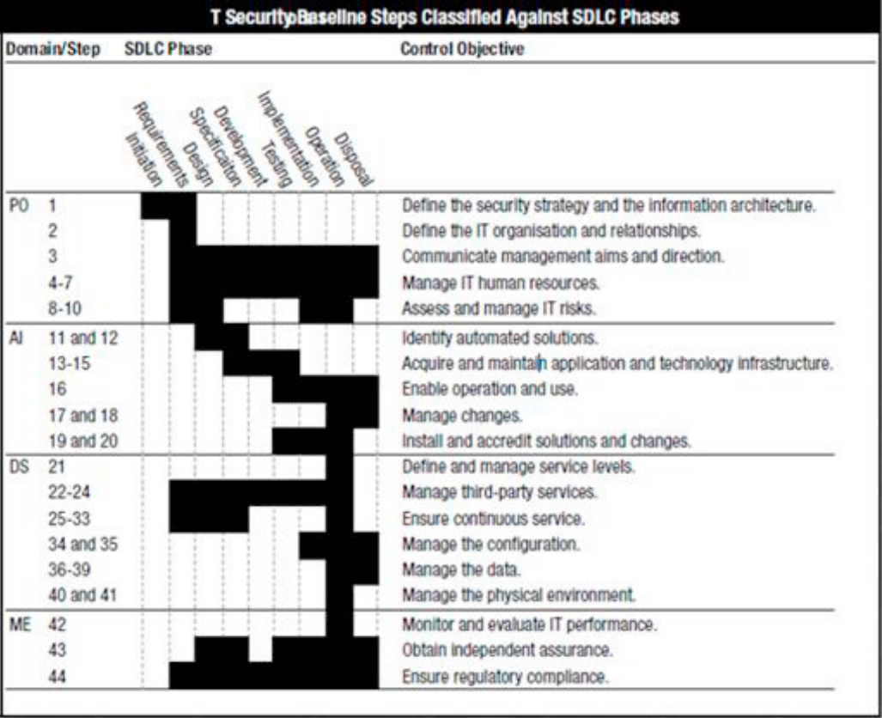
Fig. 1. Mapping the COBIT controls against SDLC phases (Watson C., 2009)
Results presented in the literature:
Solms, 2005 | COBIT as a ‘high’ level reference framework in which Information Security governance and use ISO 17799 as a ‘lower’ leveled guideline. The complementary use of COBIT and ISO 17799 is very beneficial.
James L. Parrish, Jr., John R. Kuhn, Jr., & James F. Courtney, 2008 | It proposed mindfulness as a necessary component of selecting and adjusting security policies to better predict external security threats that may arise from technological changes, environmental forces, or organizational use.
Wolden, Mark , Valverde, Raul , & Talla, Malleswara, 2015 | It investigated the effectiveness of implementing the COBIT 5 information security framework to reduce the risk of cyber-attacks against SCMS. COBIT 5 adds a new dimension to IS security governance through strict policies and rule sets, further enhancing the security of enterprise applications.
Charuenporn, P. & Intakosum, S., 2012 | In this paper, the author presented a new approach for creating Qos-SM for the measurement of Web Services based on IT practice guidelines and show the relationship between Qos ontology mapping with the COBIT ontology, and then verified the consistency of security policies in the Qos ontology and the COBIT policy by abstracting them.
Imam Riadia, Sunardib, & Eko Handoyoc, 2019 | GRR Rapid Response is the answer to internet network security. After the GRR is made, it is necessary to evaluate such a system, and the COBIT5 framework is a good standard for determining the maturity of network security.

Conclusion
In order to better grasp the use situation and direction of COBIT in today's society. This article obtained the current development direction and use measures of COBIT by investigating a large number of previous data on COBIT security.
The result of the study showed that using both COBIT and ISO17799 in an information security governance environment would lead to benefits for the companies, because the COBIT can provide the framework but not very detailed in "how" to do certain things, it is more focused on "what must be done". While, ISO17799 can just make up for the shortcomings in this regard, and provides more direct guidance for the "how".
Our method in this research was a literature review. Papers and essays about the subject "application of COBIT in the field of security" were read and taken in conclusions. The result is based on previous research about the COBIT in the field of security, and gave an indication that this is an area that proposed mindfulness as a necessary component of selecting and adjusting security policies to better predict external security threats that may arise from technological changes, environmental forces, or organizational use.
The literature itself was papers and essays about COBIT can be used in different areas, and had a positive view regarding COBIT using in security. This helped our study to have a positive outcome and our question answered, how to apply the COBIT in different areas.
Through these studies, which shows that COBIT 5 not only adds a new dimension to IS security governance through strict policies and rule sets, further enhancing the security of enterprise applications. But also a necessary component of selecting and adjusting security policies.

REFERNENCE
Charuenporn, P., & Intakosum, S. (2012). Qos-Security Metrics Based on ITIL and COBIT Standard for. Journal of Universal Computer Science, pp. 775-797.
George Mangalaraj, Anil Singh, & Aakash Taneja. (2014). IT Governance Frameworks and COBIT - A Literature Review. Twentieth Americas Conference on Information Systems. Savannah.
Imam Riadia, Sunardib, & Eko Handoyoc. (2019). Security Analysis of GRR Rapid Response Network.
James L. Parrish, Jr., John R. Kuhn, Jr. , & James F. Courtney. (2008). Mindful Administration of IS Security Policies. American conference on information systems. Toronto.
Solms, B. v. (2005). Information Security governance: COBIT or ISO 17799 or both? Computers & Security(24), 99-104.
Wolden, Mark , Valverde, Raul , & Talla, Malleswara. (2015, 06). The effectiveness of COBIT 5 Information Security Framework for reducing Cyber Attacks on Supply Chain Management System. IFAC-PapersOnLine, pp. 1846-1852.

Group no.: 7
Part of the study/paper assessed | Comments | Result
Title | Weak – needs rethinking (as it is, it is interpreted as: the security loopholes in COBIT itself). | We accept this advice and change our title.
Abstract | Vague… needs to be more specific as to what the result is of your paper.  Do you want to describe what the papers you have chosen mentions about concerning security management in COBIT? | It is a nice advice. We add more specific information about our result in Abstract and also introduce more about how and what we choose.
Introduction (background and objective) | Too general – you need to describe the background in more depth, from there you build up your problem formulation and then state the research question/s and state the contribution of this work. - you have the main points written but you need to expand your thoughts to build-up your case and you need to state your contribution and motivate it.  COBIT is not a standard but a framework.  You need to write/define what you mean by security management in your paper in the background. What is included in that? | According to the advice, we correct our definition of COBIT. Meanwhile, we discuss more about why we choose this topic and how we do the research.
Theoretical framework | Not “in-depth” - you state that your work is an extension of a paper published in 2014 because it is old (you want to check newer literature) but you only look into two newer papers (2015, 2019) - reformulate the contribution of your work to avoid this comment. | It is a good advice, so we change the state to “Then the paper explained their work in more detail and added some new researches which are published after 2014.”
Methods  Objective 5. Perform qualitative case studies | How did you do the analysis part? Could you find categories from the papers and create a table and illustrate what you found in the papers?  -you seem to have missed the point of the analysis, discussion and results. We talked about the difference between the literature review chapter in a paper and a systematic literature review, here it seems you have only done the literature review chapter part. | We accept the advice and add a net table to show these papers that we talked about. After that, we give our research method “In order to obtain effective information, the research mainly focuses on the concepts mentioned in the paper, the application fields, the verification methods and the final effects.”. And a new table was created in the middle of the paper to summarize each paper
Results  Analysis | Suggestion: Illustrate what the different papers cover through a table…  Are you showing how the development of security management has evolved since 2014? | We accept the advice and add a table to show the results froms these different papers.  Wo mainly fonce on the application of COBIT in the field of security.
Discussion and conclusion  Objective 10. Criticize results and scientific approach in investigations  Objective 11. Evaluate and reflect on some scientific articles in the field of the course | In your conclusion you are mentioning a lot about ISO77999 and COBIT, why that focus? | Sorry, it is ISO 17799. It was one of our editing errors. We mentioned it primarily to provide an example. Because COBIT can indeed be used in conjunction with other frameworks, it also leads to a better result.
Form, structure and language | (needs re-working) | Has been solved
Reference management

Content

- Does the project report clearly explain the outcome of the analysis and are the conclusions justified?
The conclusions are brief and short, and the authors do not justify why they conclude their findings.

A: Now we have add the reason.
- Are the methods used suitable and well described? Is there anything missing?
The method chapter is describing how the authors found the literature, what search terms and criteria they used which is good. They are also referencing OATES systematic approach to searching through databases. However, this approach is not described. What we lack is an analysis methodology which is not described.
A: This a good advice, so we add an analysis methodology

- Is the theoretical framework suitable for the objectives and connected to the theories and concepts we have gone through in the introductory seminars? What is good? What can be done better?
Yes, it continues the theoretical parts of the ITSM frameworks from our introductory seminars by studying the COBIT framework. We think that continuing the research is a good idea. But the research being done is to shallow for a reader to understand core concepts used. What is COBIT which version of COBIT are used? What is ISO 17799?

A: ISO17799 is June 2005, the international organization for Standardization (ISO) revised ISO/IEC17799-1 "Information security Management Implementation Rules", became the latest international standard, namely "ISO17799:2005" - information technology - security technology - information security management system implementation rules.
The COBIT version is COBIT5.
- Current description, abstract and conclusions – are they relevant to the project?
Abstract gives a brief description of what the paper is about which is good, but the abstract does not include method, results and conclusions. The introduction is good but it is a little brief and do not give the reader an understanding of what problems exist and why the author chose the subject. Conclusions are relevant but a little too brief and not problematized.
A: It is a good advice. We add methods and conclusion in our abstract and explain the reason why we chose the subject in introduction.
- Is there transparency in the report, i.e., can you follow and understand the reasoning and conclusion by the content of the report?
The conclusions feel more of a short summary of the results, however as the research question is “"What are the applications of COBIT in the field of security so far?” the conclusions are in line with the objective.

A: Because the research that we found the newest was in 2004. We cannot exactly give the application. However, we give the different areas that COBIT can be used.
- Is the conclusion reasonable and related to the objectives?
The conclusions are reasonable and related to the objectives

- How well and clearly connected are the different parts of the report?
The introduction does not include any problematization which sparks the readers interest which could be useful to give the reader incentive to read the paper. There are also no results heading so we felt confused when the results of the review showed up in the method.

- Proposed Changes/improvements
We suggest rewriting the conclusions chapter to be more specific and wider for the reader to get something new from the paper. Also include an analysis method in the method chapter and update the abstract to include method, results and conclusions. Also include a result heading.

Structure

- Reference list – References
There seems to be a mix between IEEE style referencing and APA references in the text, the authors should change all references to APA which was the referencing system to be used for the paper.
References that are not in accordance with APA. Example:
- ” information security governance environment. [2] “
- Then according to the advices from Otabes needs reference
Could be:
information security governance environment (Your Author, 2015).
Then according to the advices from Oates (2015).
A: Good advice. We change all the reference style to APA references.
- Chapter Subdivision – Headings
The paper includes an introduction, literature review, method but then the actual description of the papers found are below research method in their own headings and not under a result heading. There are references and conclusion chapters. They should include a result heading.
- Table of content
There is no need for a “Table of Contents” according to IEEE the format.
- Properly formulated and structured figures and tables. Are there references to these in the text?
There is one figure in the text and is referenced in accordance with APA.
- Appendix. Are there references to these in the text?
There is no appendix which is fine as they did not point to an appendix in the paper.
- Suggestions for changes/improvements
The paper should be structured according to the study guide from the course materials. Also, to change the references in accordance with APA.
A: We change all the reference style to APA references.

Details

- Typo:
There are some typos which the authors can address.
- Fonts:
Good Job! Seems to be in accordance with the guide.
- Size:
Looks great! size of the text is also in accordance with the guide.
- Layout:
Layout is according to the IEEE template.
- Proposed Changes/improvements:
Read through the paper and check that spelling is correct but in general the formatting of the paper looks very good!

